14.44: a) The weight of the water is

or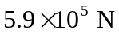 to two figures. b) Integration gives the expected result the force is what it would be if the pressure were uniform and equal to the pressure at the midpoint;

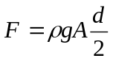

or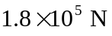 to two figures.

